The Year of the Rat is the first in the Chinese zodiac cycle. The 12 zodiac animals are, in order: Rat, Ox, Tiger, Rabbit, Dragon, Snake, Horse, Goat, Monkey, Rooster, Dog, and Pig. A Rat year occurs every 12 years.

* **Rat years:** …1912, 1924, 1936, 1948, 1960, 1972, 1984, 1996, 2008, 2020…
* **Lucky Colors:** blue, gold, green
* **Lucky Numbers:** 2, 3
* **Lucky Flowers:** lily, African violet

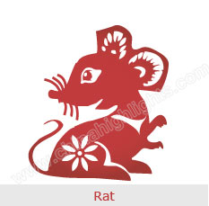

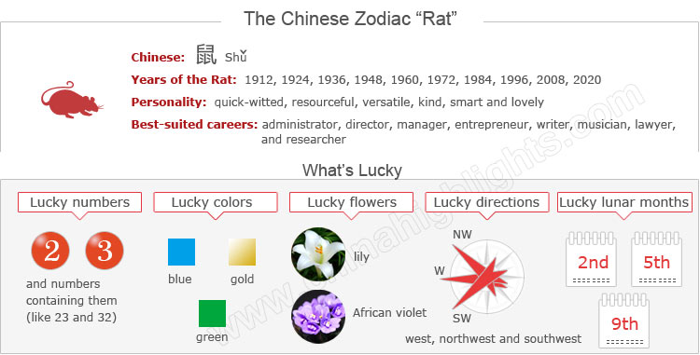

Are You a Rat?

The Chinese zodiac year is usually said to start from Chinese New Year, whose date ranges from late January to late February. Therefore, if you were born in January or February of the above years, you might be a Rat or a Pig. You can use the tool on the right to find your zodiac animal sign.

The Rat's Personality: Quick-Witted, Versatile...

Choose your date of birth and find out about your Chinese zodiac sign.



Rats are quick-witted, resourceful and versatile.

With strong intuition and quick response, they always easily adapt themselves to a new environment. With rich imaginations and sharp observation, Rats can take advantage of various opportunities well. Rats have strong curiosity, so they tend to try their hands at anything, and they can deal with it skillfully.

**Ladies** belonging to the Rat zodiac sign are pretty, smart, and lovely. They have quick minds and dexterous hands, and are able to learn anything.

A lack of courage, as well as good command skills, Rats are not capable as leaders. Opportunistic and picky as Rats are, they do not have broad minds, but a narrow view.

Rats are kind, but sometimes impolite to others. People of the Rat zodiac sign usually sleep late, for mice are nocturnal animals.

Good Health for "Rats"

General speaking, Rats are healthy. They are full of energy and active, which helps them keep fit and avoid illness.

**A balanced diet and regular exercise benefit Rats**. With enough rest Rats can keep high spirits at work, which can improve work efficiency. When in stressful and tense conditions, Rats are suggested to take a tour to free stress and tension.

**In dry seasons**, Rats should pay attention to prevention of respiratory and skin problems.

Best-Suited Careers for "Rats"

With good insight and sharp perspective, Rats have good judgment in what they do, which enables them to prevent unnecessary troubles. Rats are cautious and meticulous, so they tend to show a serious attitude toward their work.

**The best careers for Rats are**: administrator, director, manager, entrepreneur, broadcaster, writer, musician, stand-up comedian, politician, lawyer, researcher, and racing car driver.

How to Build Relationships with "Rats"

With an active nature, **Rats enjoy a flexible social circle**. They are interested in attending different kinds of social occasions. They like to make new friends, but they seldom further their relationships with others. Rats have a charming appearance, which can attract more friends.

**In love relationships**, Rats find it easy to start a new relationship with someone, but they also break off relationships easily, which results in trouble with infidelity.

Are Rats Compatiblabe with You?

Love compatibility within the Chinese zodiac animals takes the unique characteristics of each animal into account. Those whose characteristics match well can have good compatibility.

However, those who don’t match need to put more effort into their relationships.

See below the compatibility of the Rat with other animals, and find out if the Rat is compatible with your sign or not.

* **Best with:** Ox, Dragon, Rabbit
* **Worst with:** Horse, Rooster

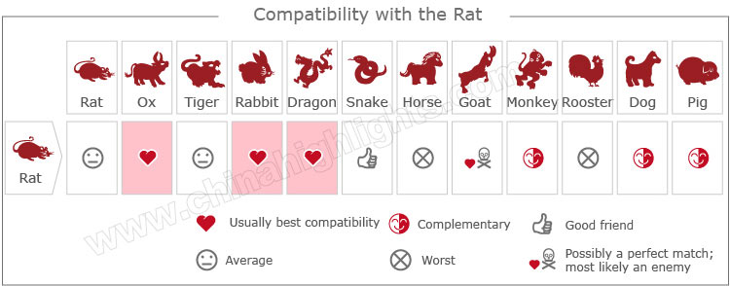

[Take our online love Compatibility test](http://www.chinahighlights.com/travelguide/chinese-zodiac/compatibility.htm)

The Luckiest Things for "Rats"

* **Lucky numbers:** 2, 3, and numbers containing them (like 23 and 32)
* **Lucky days:** the 4th and 13th of every Chinese lunar month
* **Lucky colors:** blue, gold, green
* **Lucky flowers:** lily, African violet
* **Lucky direction:** west, northwest and southwest
* **Lucky months:** the 2nd, 5th and 9th Chinese lunar months

Things that "Rats" Should Avoid

* **Unlucky color:** yellow, brown
* **Unlucky numbers:** 5 and 9
* U**nlucky direction:** south and southeast
* **Unlucky months:** the 4th, 10th, and 12th Chinese lunar months

2015 for "Rats" — an Unstable Year

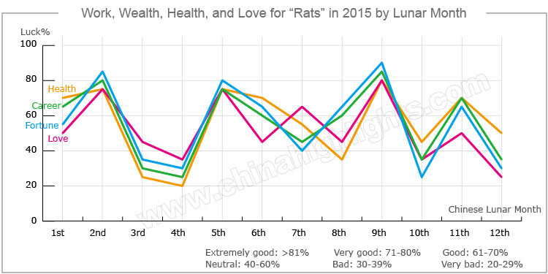

In 2015, the overall fortune in all aspects for people born in a year of the Rat is not very good. Good fortune in money and career will be limited. They will have chances to get promotions, but need to work hard for them. Their physical condition is predicted not to be very good. They should pay more attention to their health.

Love and Relationships

**Rats will have better love relationships** in 2015 than in 2014, but still not particularly good.

**Single Rats** will have chances to meet several partners, but it will be hard to meet the right one.

**Both married couples and people in love** are likely to have quarrels with each other, but fortunately their relationships won't be hurt. Lovers and couples should spend more time to communicate with each other, and show more care and tolerance for their partners.

Unstable Money-Making Opportunities

The monetary fortune for people born in a year of the Rat is fickle in 2015.

People who were born in a year of the Rat should be **very cautious** when investing venture capital. The greater the chance to make money, the calmer they should stay. They should only make a move after investigating thoroughly to avoid suffering unexpected financial losses, and, therefore, should never act without thought.

However, fortune for Rats is good enough in **the 2nd, 5th, and 9th Chinese lunar months** for Rats to make money. People who operate businesses can plan some important business and investments in these months.

In addition, Rats should watch out for thieves and take care of their valuable possessions.

Good Career Path for "Rats" in 2015

As for career, even though luck for Rats will be limited, they will have **more opportunities than ever**. Rats will have excellent performance at work, which will make their leaders and bosses attach importance to them. Promotions are expected for them.

However, their jobs may bring them **pressure**. So Rats should relax themselves properly and avoid overwork to keep fit.

In daily work, Rats should **keep good relationships** with their colleagues and bosses. They should pay attention to their words and actions to avoid unnecessary arguments.

More Health Risks for "Rats" in 2015

Rats' health will tend to be **easily harmed**, so Rats should pay attention to their physical condition in 2015. They should be careful in work, or they will easily get hurt.

Due to lots of pressures in work, Rats should have **enough rest** and relax after work. They are also suggested to do **more exercise** in order to prevent diseases resulting of the urinary system and feet, and keep a healthy diet.

Five Types of "Rat", Which One Are You?

In Chinese element theory, each zodiac sign is associated with one of the five elements: Wood, Fire, Earth, Gold (Metal), and Water. For example, a Wood Rat comes once in a 60-year cycle.

It is theorized that a person's characteristics are decided by their birth year's zodiac animal sign and element. So there are five types of Rat, each with different characteristics:

|  |  |  |
| --- | --- | --- |
| **Type of Rat** | **Year of Birth** | **Characteristics** |
| Wood Rat | 1924, 1984 | Independent, self-confident, virtuous and talented, with a strong sense of teamwork |
| Fire Rat | 1936, 1996 | Energetic, brave, quiet, cordial and friendly to their friends, but very strict with themselves |
| Earth Rat | 1948, 2008 | Amiable, honest, flexible, modest, serious, with a strong sense of self-esteem |
| Gold Rat | 1960, 2020 | Smart, talented, hot-tempered, jealous, with a strong sense of self-awareness |
| Water Rat | 1912, 1972 | Talkative, shrewd, conservative, and wise |

See [2015 Predictions for Rats of Different Elements](http://www.chinahighlights.com/travelguide/chinese-zodiac/five-lements-character-destiny-analysis-rat.htm).

Are Rat Years Unlucky Years for Rats?

According to Chinese astrology, the year of their birth sign (本命年běnmìngnián /bnn-ming-nyen/ ‘origin (of) life year’) will bring people nothing but bad luck. It is believed that people will offend Tai Sui, the God of Age, in their benmingnian.

Therefore, Rats should pay special attention to avoid misfortune in their lives in the year of their birth sign. The next Rat year is 2020. It starts on Chinese New Year (January 25). Read more on [How to Be Lucky in Your Ben Ming Nian](http://www.chinahighlights.com/travelguide/chinese-zodiac/how-to-bring-yourself-good-luck-on-ben-ming-nian.htm).