The Snake occupies the sixth position in the Chinese Zodiac. The 12 zodiac animals are, in order: Rat, Ox, Tiger, Rabbit, Dragon, Snake, Goat, Monkey, Rooster, Dog, and Pig. Each year is related to a Chinese zodiac animal according to the 12-year-cycle.

* **Lucky Colors:** black, red, and yellow
* **Lucky Numbers:** 2, 8, 9
* **Lucky Flowers:** orchid and cactus
* **Years of Birth:** ...1917, 1929, 1941, 1953, 1965, 1977, 1989, 2001, 2013, 2025...

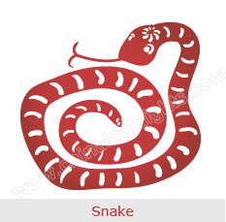

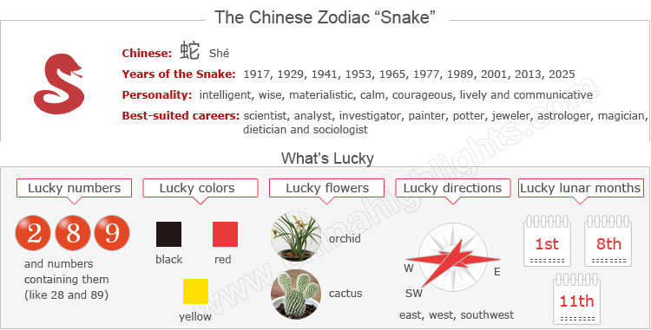

Are You a Snake?

Are Snake Years Unlucky Years for Snakes?If you were born after February 20, the latest date of Chinese New Year, when the zodiac year starts, in the above years (or before Chinese New Year in a year following those above) then you are a Snake. If, however you were born from January 1 to February 20, in one of the above years, you could be a Dragon — the previous zodiac sign.

You can use the tool on the right to find your zodiac animal sign.The year of one’s birth sign (本命年 běnmìngnián /bnn-ming-nyen/ ‘origin (of) life year’) is believed to be **the most unlucky in the 12-year cycle**. Therefore Snakes should be more careful about all aspects of their lives, including love, health, career and finance. Read more on How to Be Lucky in Your Ben Ming Nian.

Choose your date of birth and find out about your Chinese zodiac sign.



The next Snake year is 2025. It starts on Chinese New Year (January 29).

The Snake's Personality: Intelligent, Wise...

In Chinese culture, the Snake is the most enigmatic animal among the twelve zodiac animals. People born in a year of the Snake are supposed to be the most intuitive.

Snakes tend to act according to their own judgments, even while remaining the most private and reticent. They are determined to accomplish their goals and hate to fail.

Snakes represent the symbol of wisdom. They are intelligent and wise. They are good at communication but say little. Snakes are usually regarded as great thinkers.

Snakes are materialistic and love keeping up with the Joneses. They love to posses the best of everything, but they have no patience [for shopping](http://www.chinahighlights.com/travelguide/chinese-zodiac/snake.htm).

Snake people prefer to work alone, therefore they are easily stressed. If they seem unusually stressed, it is best to allow them their own space and time to return to normal.

Good Health for "Snakes"

Snakes prefer living a peaceful life, and they do not like a noisy environment. Snakes become easily stressed when their lives aren’t calm or in order. Therefore, a manageable workload would be good for them rather than a challenging schedule.

Snakes need to spend lots of time to relax themselves. It's necessary to take vacations at the proper time. People should pay attention to the health of Snake people, especially senior members in the family.

The Best Careers for "Snakes"

Snakes are very creative and extremely diligent. Though Snakes work very hard, they have a tendency to be job-hoppers, as they easily become bored. Snakes are great thinkers. Complex problems stimulate them. And of course they’re excellent problem-solvers and thrive under tight deadlines.

**Good career choices** for Snakes include: scientist, analyst, investigator, painter, potter, jeweler, astrologer, magician, dietician, and sociologist.

How to Build Relationships with "Snake People"

People born in the year of the Snake do not have a lot of friends. It is extremely hard to get to know them because they keep their feelings locked up inside. Snakes are careful in choosing friends. They will never forgive a breach in friendship.

Once people are his/her friends, the Snake is willing to share his sorrow and happiness with them. Snake people guard their chosen friends much like valuable possessions, and they are easily jealous and even obsessive.

The Luckiest Things for "Snakes"

* **Lucky numbers:**2, 8, 9, and numbers containing them (like 28 and 89)
* **Lucky days:**the 1st and 23rd of Chinese lunar months
* **Lucky colors:** black, red, and yellow
* **Lucky flowers:** orchid and cactus
* **Lucky direction:** east, west, and southwest
* **Lucky months:**the 1st, 8th, and 11th lunar months

The Unlucky Things for "Snakes"

* **Unlucky color:** brown, gold, white
* **Unlucky numbers:** 1, 6, and 7
* **Unlucky direction:** northeast and northwest
* **Unlucky months:** the 3rd, 9th and 12th lunar months

Is 2015 a Lucky Year for "Snakes"?

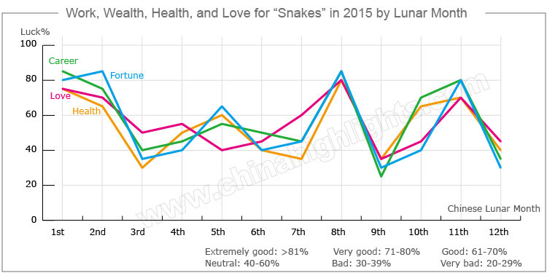

According to Chinese astrology, 2015 will be a very **challenging and unstable year** for people born in the year of the Snake. The overall fortune of Snakes will not be good. Snakes should be calm and patient when they confront troubles in their lives.

Love and Relationships

The romantic lives of Snakes will not be very smooth in 2015, especially for single Snakes. So **single Snakes** should participate in more social activities and meet new friends, which will help them get more chances to meet their love.

For **Snakes in love**, their relationships will be unstable. They should spend more time communicating with each other to maintain a harmonious relationship.

**Married couples** should care more about each other in order to keep a good marriage, or there will be extramarital affairs.

Snakes are more likely to get into trouble in their relationships in the following Chinese lunar months of 2015: 3rd, 4th, 7th, 10th, and 11th.

Bad Money-Making Opportunities

People who were born in a year of the Snake will have bad luck in their finances in 2015. Snakes should be careful when they cooperate with others in case of being cheated.

Snakes will be prone to spend more money than they earn. Therefore, Snakes should make a good financial plan and control their expenses well. They should [purchase](http://www.chinahighlights.com/travelguide/chinese-zodiac/snake.htm) something valuable at the beginning of the year that will increase in value by the end of the year. Snakes should also be careful to make money legally, and then good fortune will find its way to them eventually.

Good financial fortune is more likely to occur in the 1st, 8th, and 11th Chinese lunar months. Snakes should think about making some wise investments and planning some important business events in these months.

Tough Career Paths for "Snakes" in 2015

As far as the career of Snakes is concerned in 2015, fortune is predicted to never fall upon them in 2015, and one calamity will come on top of another for them. There will be little chance for Snakes to have a salary increase or promotion.

They must try their best to save their jobs, which are at risk from bad performances in 2015. They should work hard as usual and make progress little-by-little.

It is also advisable for Snakes to maintain a good relationship with their colleagues and leaders.

Bad Health for "Snakes" in 2015

Snakes’ health will tend not to be very good. Some chronic diseases may befall them. They should go to see the doctor immediately when they feel unwell.

Snakes should be careful when driving and avoid risky sports, such as diving and riding, in order to prevent accidents. As for their daily life, they should slow down when doing things so as to reduce the chance of injury.

Love Compatibility of the Snake with Other Animals

Each animal sign has its unique characteristics. Love compatibility within the Chinese zodiac animals takes the characteristics of each animal into account. Only those whose characteristics match can be good partners.

See below the compatibility of the Snake with other animals, and find out if the Snake is compatible with your sign or not.

* **Best with:**Dragon, Rooster
* **Worst with:**Tiger, Rabbit, Goat

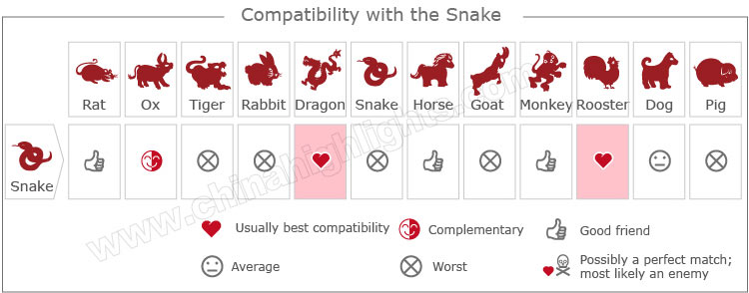

[Take our online love Compatibility test](http://www.chinahighlights.com/travelguide/chinese-zodiac/compatibility.htm)

Five Types of "Snake" — Which One Are You?

In Chinese element theory, each zodiac sign is associated with one of the five elements: Gold (Metal), Wood, Water, Fire, and Earth. For example, a Wood Snake comes once in a 60-year cycle.

It is theorized that a person's characteristics are decided by their birth year's zodiac animal sign and element. So there are five types of Snakes, each with different characteristics:

|  |  |  |
| --- | --- | --- |
| **Type of Snake** | **Year of Birth** | **Characteristics** |
| Wood Snake | 1905, 1965 | Orderly, intelligent, with a gift for appreciating the arts and a refined taste |
| Fire Snake | 1917, 1977 | Smart, insightful, communicative, active, and fond of the limelight |
| Earth Snake | 1929, 1989 | Calm, with strong self-control, but not steadfast and diligent enough in work |
| Gold Snake | 1941, 2001 | Determined, courageous, confident, and able: a born leader |
| Water Snake | 1953, 2013 | Clever, creative, lively, and communicative, but sentimentaL |