The Pig is the last animal sign on the Chinese zodiac. The 12 zodiac animals are, in order: Rat, Ox, Tiger, Rabbit, Dragon, Snake, Horse, Goat, Monkey, Rooster, Dog, and Pig; forming a 12-year-cycle. "The Year of the Pig" is not any particular year in history, but a position in the zodiac cycle.

* **Years of the Pig:** 1923, 1935, 1947, 1959, 1971, 1983, 1995, 2007, 2019, 2031

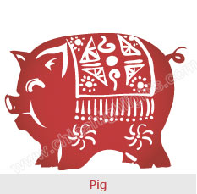

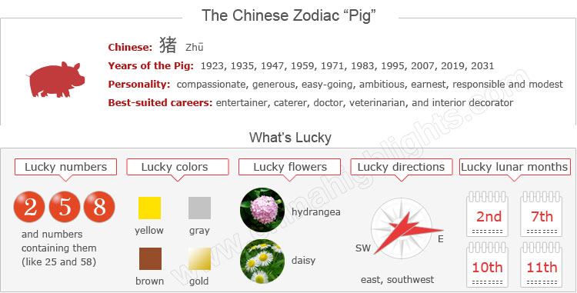

Are You a "Pig"?

It is not quite as simple as being born in one of the above years, because the Chinese zodiac year is usually said to start from Chinese New Year in January or February, according to the Chinese lunar calendar. You can use the tool on the right to find your zodiac animal sign.

The Pig’s Personality: Compassionate, Generous...

Choose your date of birth and find out about your Chinese zodiac sign.



Pigs are diligent, compassionate, and generous. They have great concentration: once they set a goal, they will devote all their energy to achieving it. Though Pigs rarely seek help from others, they will not refuse to give others a hand. Pigs never suspect trickery, so they are easily fooled.

General speaking, Pigs are relatively calm when facing trouble. No matter how difficult the problems are Pigs encounter, they can handle things properly and carefully. They have a great sense of responsibility to finish what they are engaged in.

Good Health for "Pigs"

Pigs generally have good health all through life, if they avoid excess. While they have frequent dinner parties and social activities, they should avoid excessive eating, drinking, and smoking, which can cause sickness. In addition to a balanced diet, proper exercise is badly needed for Pigs to keep fit.

As Pigs have a free mind on everything, they rarely encounter stress trouble. Faced with work overload, they know how to relax themselves from tiredness. Sleep is a usual way for them to refresh themselves.

Best-Suited Careers for "Pigs"

**Pigs enjoy fine fortune in their careers**. Their work and cause develop in a relatively smooth way.

**When encountering trouble and difficulties**, Pigs tend to receive help from others. With a great sense of responsibility, Pigs are not afraid to try to do what they are interested in, and Pigs have rich creativity and imagination.

**In social relationships**, they should build up their own interpersonal network to help them achieve career success.

**They thrive as** entertainers, caterers, doctors, veterinarians, and interior decorators. Promising career fields include transportation, entertainment, retail and hospitality.

How to Build Relationships with “Pigs”?

Pigs enjoy good social relationships, so you don’t need to try very hard. With traits of sincerity and integrity, they are popular friends. Pigs are clear-minded, and not preoccupied with minor things that concern other people. They value friendship highly and never betray friends unless in special circumstances.

In love relationships pigs are affectionate and sexual. They are faithful to their partners. Once they find the right partner, they’re typically committed for the long-term. However, due to lack of proper communication, sometimes Pigs cannot handle problems in relationships.

If you want to have a long-term relationship with a Pig, be honest with and have knowledge of his/her inner thoughts.

Are Pigs Compatible with You?

Love compatibility within the Chinese zodiac animals takes the unique characteristics of each animal into account. Those whose characteristics match well can be good partners. See below the compatibility of the Pig with other animals, and find out if the Pig is compatible with your sign or not.

* **Best match:** Goat, Tiger, Rabbit
* **Worst match:** Monkey, Snake

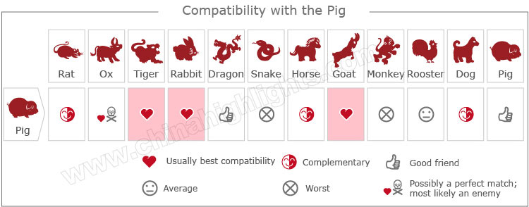

[Take our online love Compatibility test](http://www.chinahighlights.com/travelguide/chinese-zodiac/compatibility.htm)

The Luckiest Things for "Pigs"

* **Lucky numbers:** 2, 5, 8, and numbers containing them (like 25 and 58)
* **Lucky days:** the 17th and 24th of every Chinese lunar month
* **Lucky colors:** yellow, gray, brown, gold
* **Lucky flowers:** hydrangea and daisy
* **Lucky direction:** east and southwest
* **Lucky months:** the 2nd, 7th, 10th, and 11th Chinese lunar months

The Unlucky Things for "Pigs"

* **Unlucky color:** red, blue, green
* **Unlucky numbers:** 1, 7, and 8
* **Unlucky direction:** southeast
* **Unlucky months:** the 4th, 9th, and 12th Chinese lunar months

Is 2015 a Lucky Year for "Pigs"?

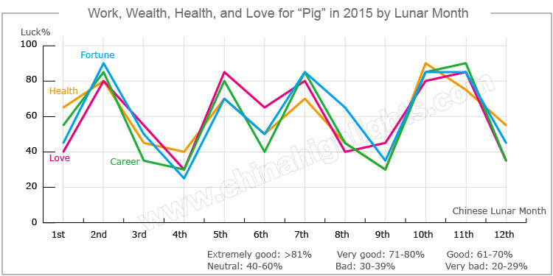

**Yes, 2015 is a very fortunate year for people born in a year of the Pig.** Their professional life will be pretty fine, they will have good relationships with influential persons in their fields — all things will go positively. But what Pigs need to do is to act maturely and make decision cautiously.

Love and Relationships

Romance will be very good for Pigs in 2015.

**Single Pigs** will meet their true love. They should attend more social events and pay attention to people of the opposite sex around them, because one of them may be their right person.

**For people in love**, it will be an ideal time to get married.

**Married couples** may have some arguments with each other from time to time. They should have more communication with their partners to avoid any misunderstandings. Tolerance is also necessary to keep a harmonious marriage.

Money-Making Opportunities

**In general, monetary prospects for Pigs in 2015 are good.** Pigs may find that this year is the time where their investments pay off. Excellent profits can be made and their income will increase. They also have an increased chance to earn extra income.

Although Pigs may suffer some unexpected financial losses, they will get help from wealthy benefactors and quickly recover from the losses. Although fortune favors Pigs in 2015, it will not be good to be reckless with money. They are advised to have a good financial plan.

Good Career Paths for "Pigs" in 2015

Pigs’ careers will tend to be good in 2015.

Pigs looking for jobs will find good opportunities that fit them well.

**Clerks** will performance well in their jobs, and they are expected to get salary increases and promotions this year. They can also get additional income by doing some part-time jobs.

**Pigs operating businesses** will have a good year for expansion, and excellent profits can be made.

**Pigs should always** play to the score and head off danger at critical moments due to being able to handle affairs neatly and maturely. They should keep a good relationship with their bosses and colleagues.

Good Health for "Pigs" in 2015

Overall health for Pigs is good throughout the year. Pigs may have some pressure from work, so there will be emotional ups and downs. They should control their emotions well, and remember to rest the body and recharge after work.

Pigs should pay special attention to their digestive system and nervous system, particularly stomach, spleen, and muscles, and avoid strenuous exercises. They will quickly recover from illnesses due to help from good doctors.

Five Types of "Pig", Which One Are You?

In Chinese element theory, each zodiac sign is associated with one of the five elements: Gold (Metal), Wood, Water, Fire, and Earth. For example, a Wood Pig comes once in a 60-year cycle.

|  |  |  |
| --- | --- | --- |
| **Type of Pig** | **Year of Birth** | **Characteristics** |
| Wood Pig | 1935, 1995 | Good-natured, lovely, easy-going, generous, brave but irritable |
| Fire Pig | 1947, 2007 | Ambitious, persevering, but impatient |
| Earth Pig | 1959, 2019 | Communicative, popular among their friends, with a strong sense of timekeeping |
| Gold Pig | 1911, 1971 | Broad-minded, amicable, and willing to help others |
| Water Pig | 1923, 1983 | Gentle, modest, earnest, responsible, but subjective in life |

It is theorized that a person's characteristics are decided by their birth year's zodiac animal sign and element. So there are five types of Pigs, each with different characteristics: